STA 231- Practical exam batch 2

1. Use the SPSS file and make atleast 3 different graphs.

2. 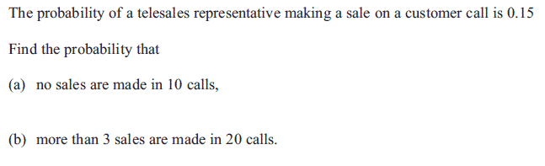

3. 